TASK 1

BASIC OPERATIONS OF POWERBI

STEP 1: OPEN THE POWERBI CLICK ON THE GET DATA BUTTON ON TOOL BAR AND ACCESS THE DATA FROM LOCAL STORAGE.

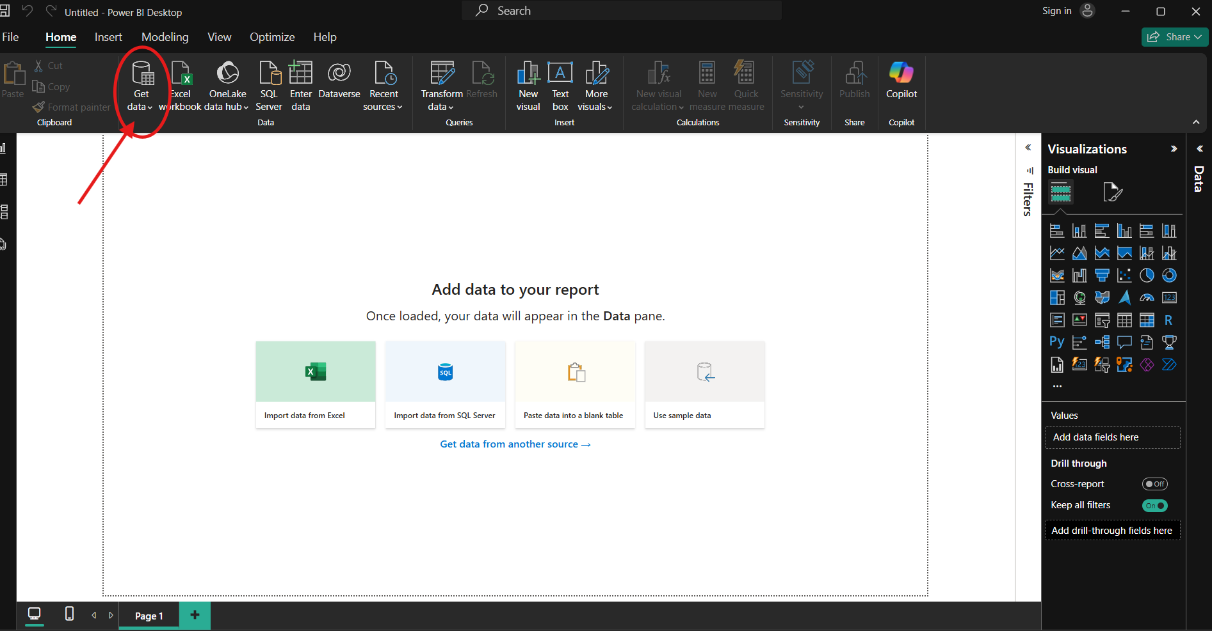

STEP 2: AFTER CLICKING THE GET DATA YOU NEED TO CHOOSE AN OPTION.SELECT THE OPTION TEXT/CSV SO THAT YOU CAN ACCESS THE DATA FROM LOCAL STORAGE BEFORE THAT DOWNLOAD THE DOCUMENT.

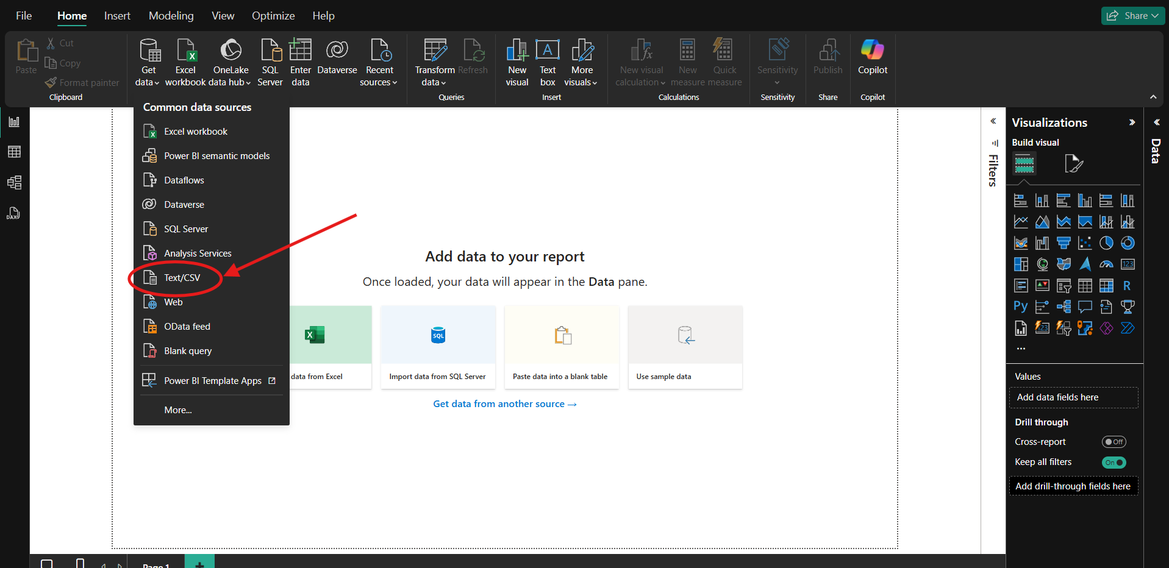

STEP 3: SELECT THE DOCUMENT FROM LOCAL PC AND OPEN IT.

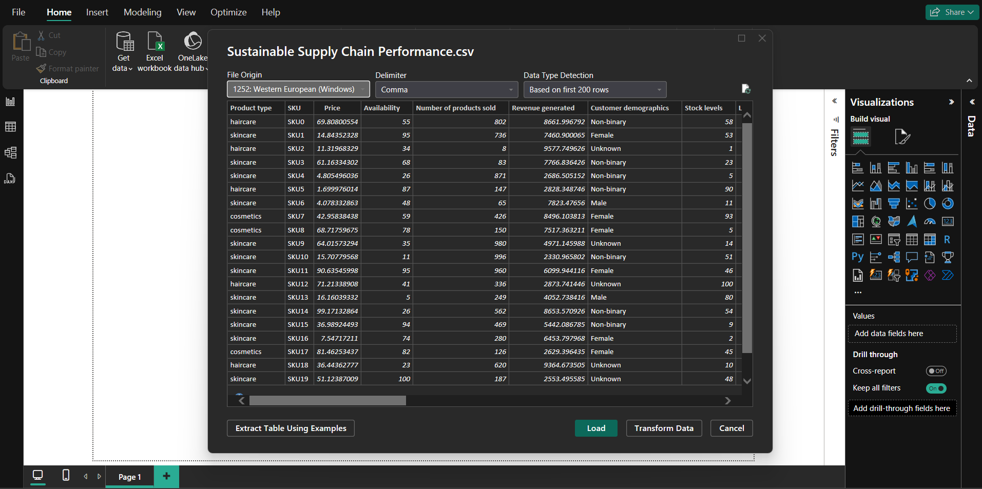

STEP 4: OPEN THE CSV FILE BY CLICKING THE TRANSFORM DATA TO CLEAN THE DATA CLICK ON REMOVE SO THAT IT REMOVE VARIOUS KINDS OF MISSING VALUE DUPLICATE DATA WHEN YOU WANT YOU CAN REMOVE COLOUMN AND ROW.

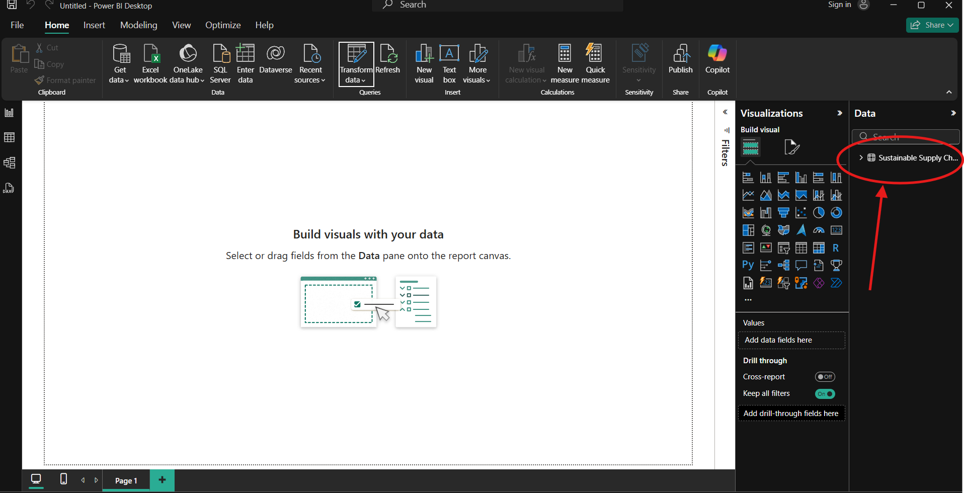

YOU CAN VIEW THE LOADED DOCUMENT

STEP 5: GO TO TRANSFORM DATA AND YOU WILL GET THE SUSTAINABLE SUPPLY CHAIN PERFORMANCE DOCUMENT

NOW RIGHT CLICK ON THE DOCUMENT AND CLICK ON DUPLICATE SO THAT YOU WILL GET ANOTHER DUPLICATE FILE RENAME IT.

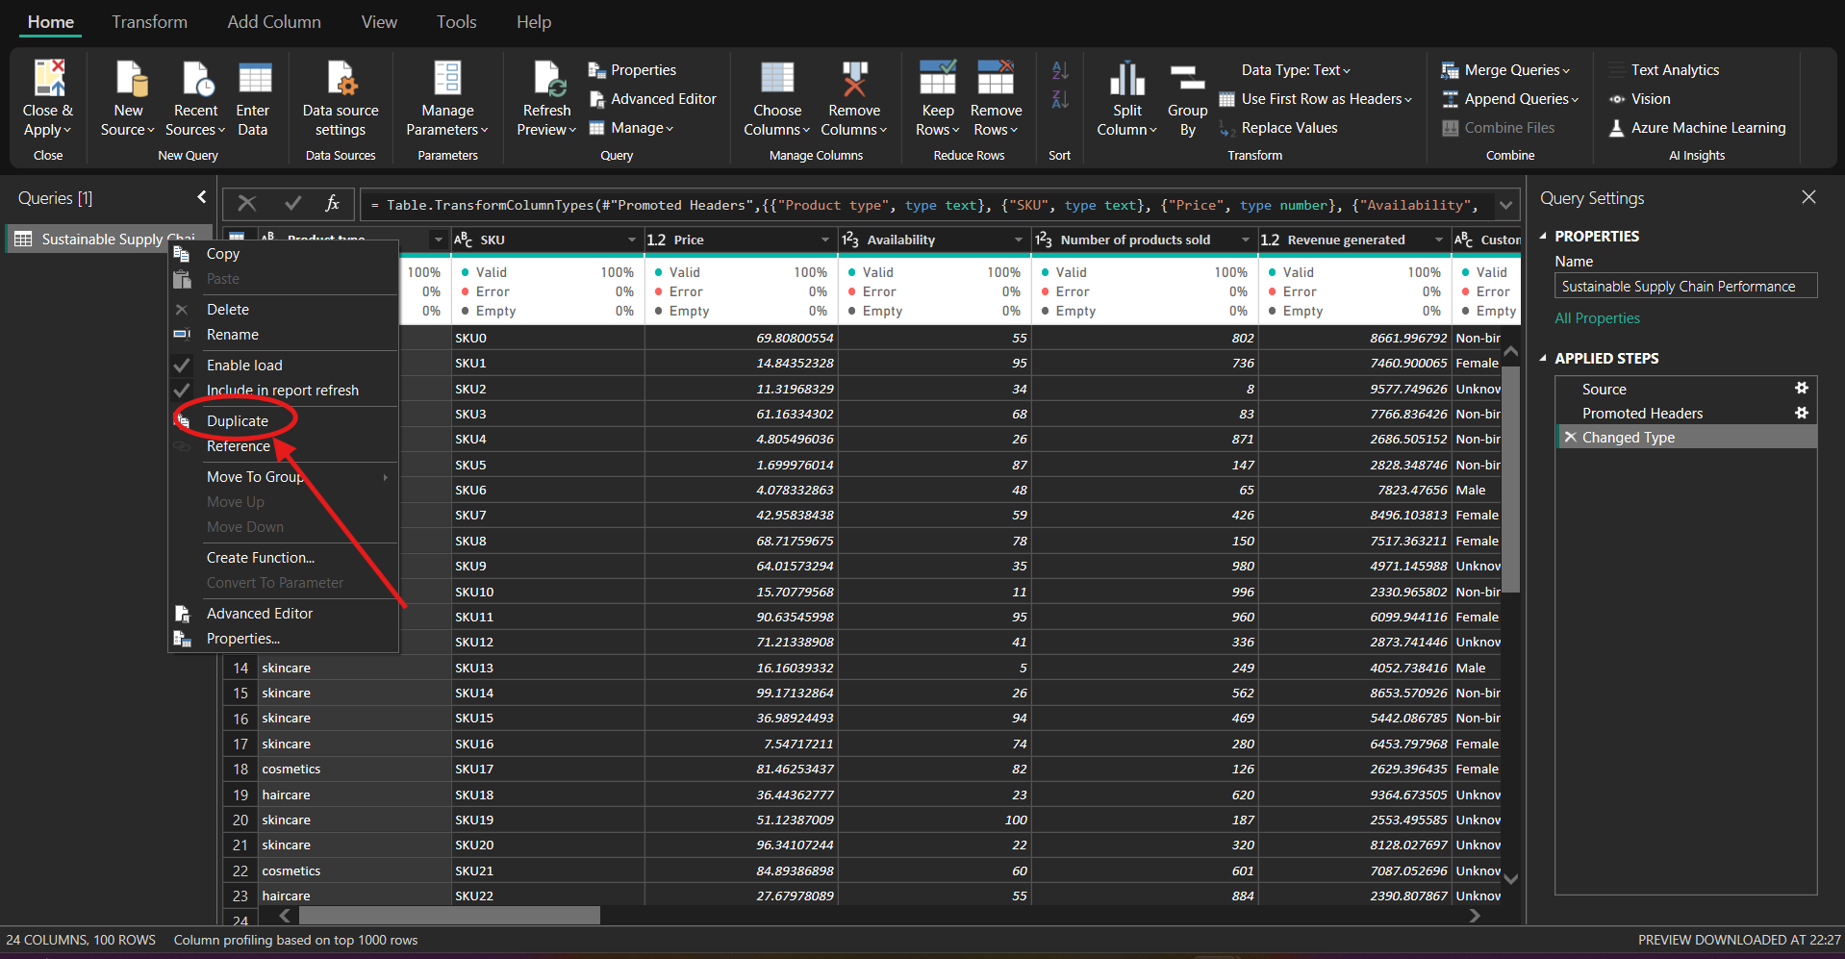

STEP 6: RENAME THE DUPLICATE FILE AS INVENTORY AND KEEP COLUMNS THAT ARE NEEDED AND REMOVE NOT REQUIRED COLOUMS.

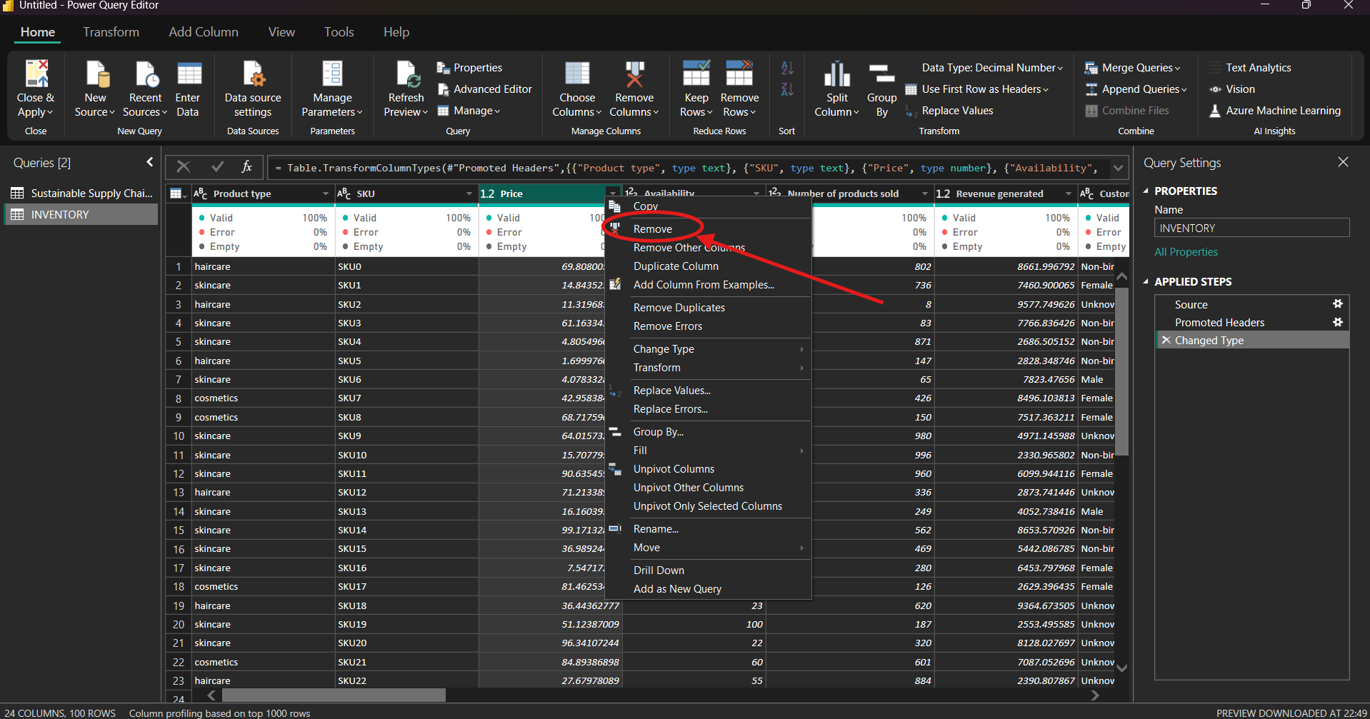

SO THAT THE COLUMN WILL BE REMOVED.

STEP 7: LIKE WISE BY RIGHT CLICKING THE SUSTAINABLE SUPPLY CHAIN CREATE MANUFACTURE TABLE, SUPPLIER TABLE AND SUPPLY CHAIN TABLE AND REMOVE THE UNREQUIRED COLOUMNS.

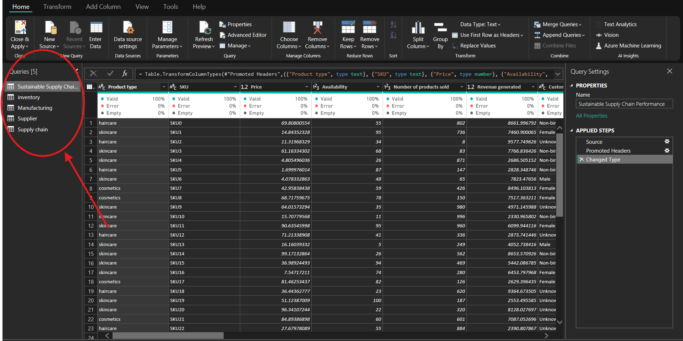

STEP 8: CLICK ON CLOSE AND APPLY SO THAT IT WILL LOAD ALL THE MODIFICATIONS DONE IN THE TABLES LIKE INVENTORY MANUFACTURE AND SUPPLIER AND SUPPLY CHAIN TABLES.

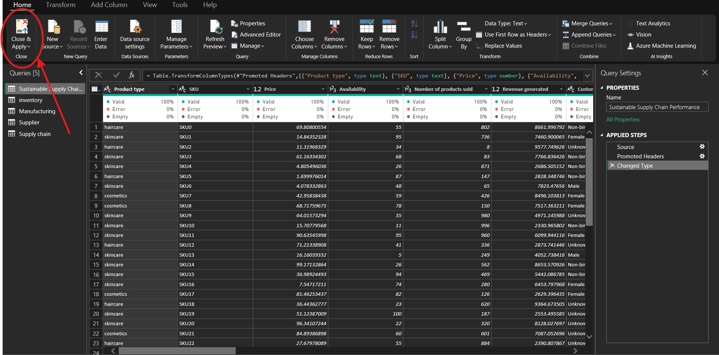

HERE WE CAN VIEW OUR REQUIRED DATA

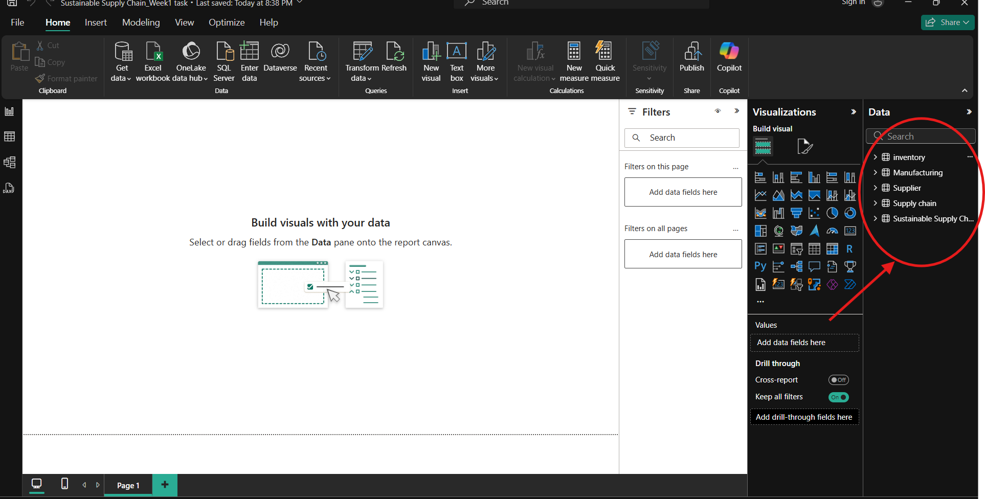

GO TO FILE CLICK ON SAVEAS AND SAVE THE FILE.

HENCE REQUIRED TASK IS COMPLETED.